General issues:

* When the student refresh the webpage or use the backward or forward navigation of the browser, the webpage become blank or Show the 404 page not found error.
* After completing all the Sections first Practice, the navigation button is written wrongly, must write redirect to next Practice stage (Continue to Practice 2).

Other issues:

1. Section1.explanation.example3: after completion, the navigation is not redirecting to the Section1.Practice1
2. Section1.Explantion: We need to update the solving steps description and the hints to be more meaningful like we did in the other sections.

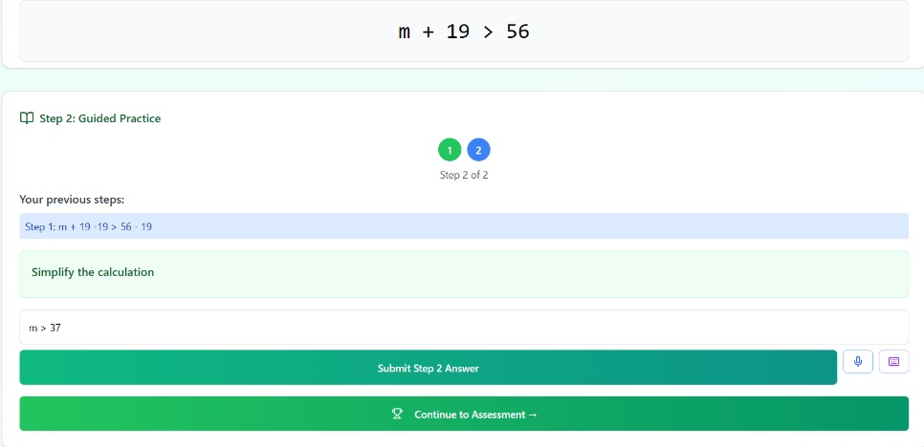

1. Due to duplicate name of the Section1.Practice2 and Section2.Practice2, the assessment and the examprep of Section1 is locked. The Section1.Practice2 is solved correctly, but cannot redirect to the assessment. İnstead it redirect to the Section2.prep.
2. Update the Section2.Example3: create a new inequality with variables from 2 sides. Allow 3 steps fort he solution.
3. Section2.explanation.example3: after completion, the navigation is not redirecting to the Section2.Practice2_1

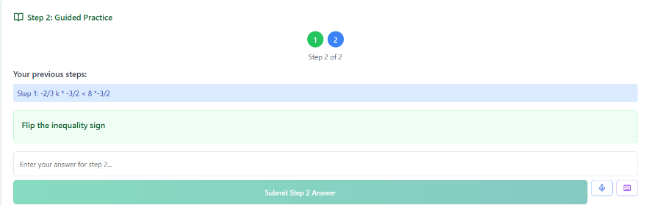

1. The step 2 instruction is not correct (Flip the inequality sign), it should be “Simplify the inequality”.
2. After completing Section2.Practice2_1, the navigation button is written wrongly, must write redirect to Section2.Practice2_2
3. Section3.explanation.example3: after completion, the navigation is not redirecting to the Section3.Practice3_1

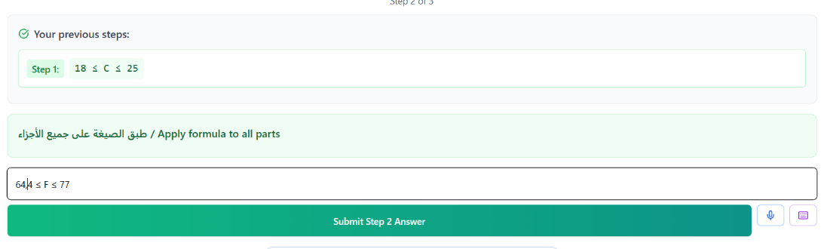

1. There is an issue in the validation here: it did not accept the correct answer: 64.4 ≤ F ≤ 77. In the code there are 2 options: 64.4 ≤ F ≤ 77 & 64 ≤ F ≤ 77: not correct.
2. Section5.Explantion.Example2: accept only one answer: n ≤ -2 or n ≥ 2. If I write the first inequality after the second one, system not accept it.
3. Section5.Practice5_2, the problem Word, we have to add the variable name L in the problem description.

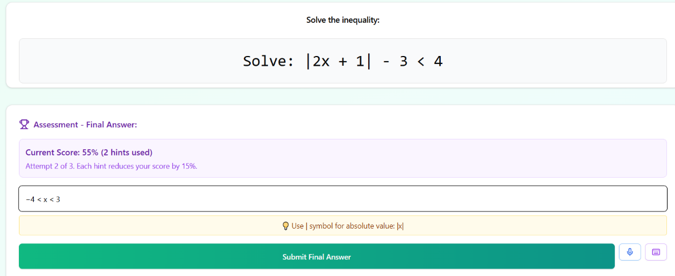

1. Section5.examprep, solution correct but not accepted.
2. We want to add a chart for each example (after submitting the final answer in all the stages).